ASSIGNMENTS

Name: Suruthi V

NM-ID : 88A47BC9080CDE499E844AF1A08CEE03

Brand Name: CoffeeDay

Assignment 1:Blog Creation

Link: https://cheerswithcoffeeday.blogspot.com/2023/10/welcome-to-coffeeday-where-every-sip-is.html
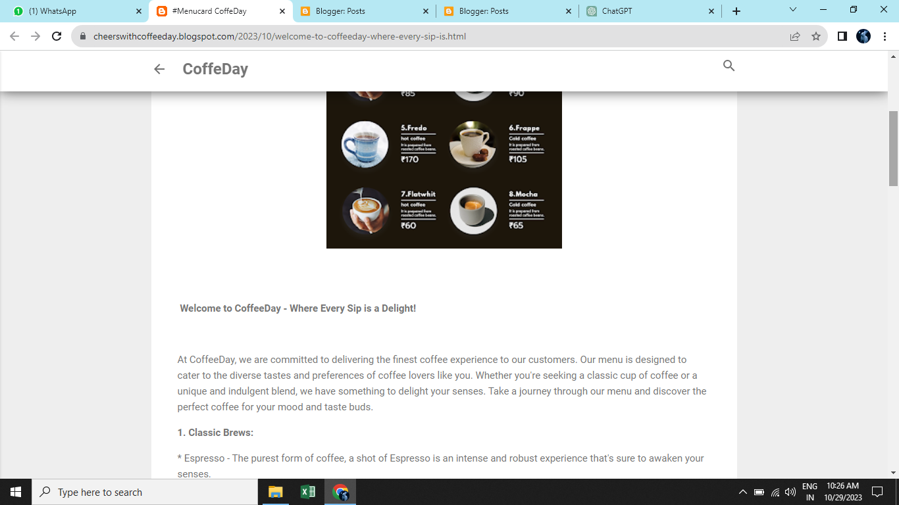

Assignment 2: Facebook Business Page Creation
Link: https://www.facebook.com/your.CoffeeDay
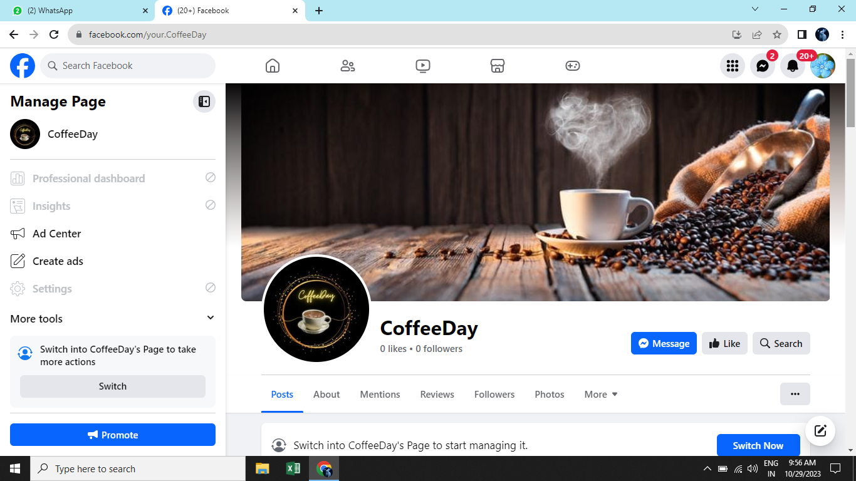

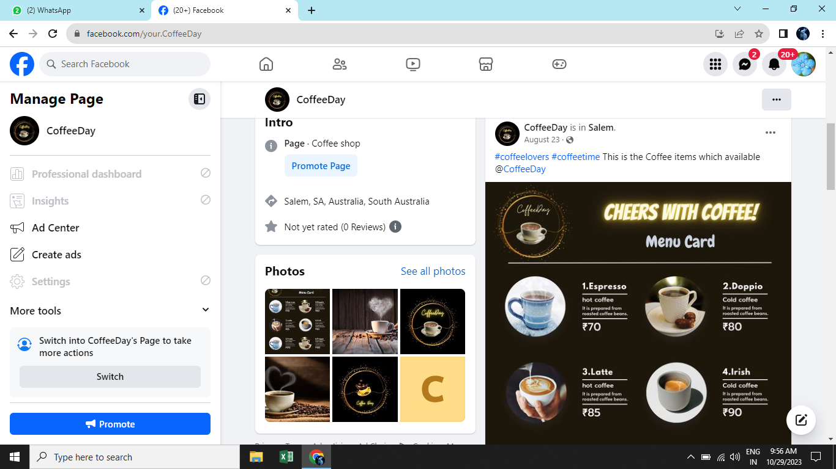

Assignment 3: Poster Creation

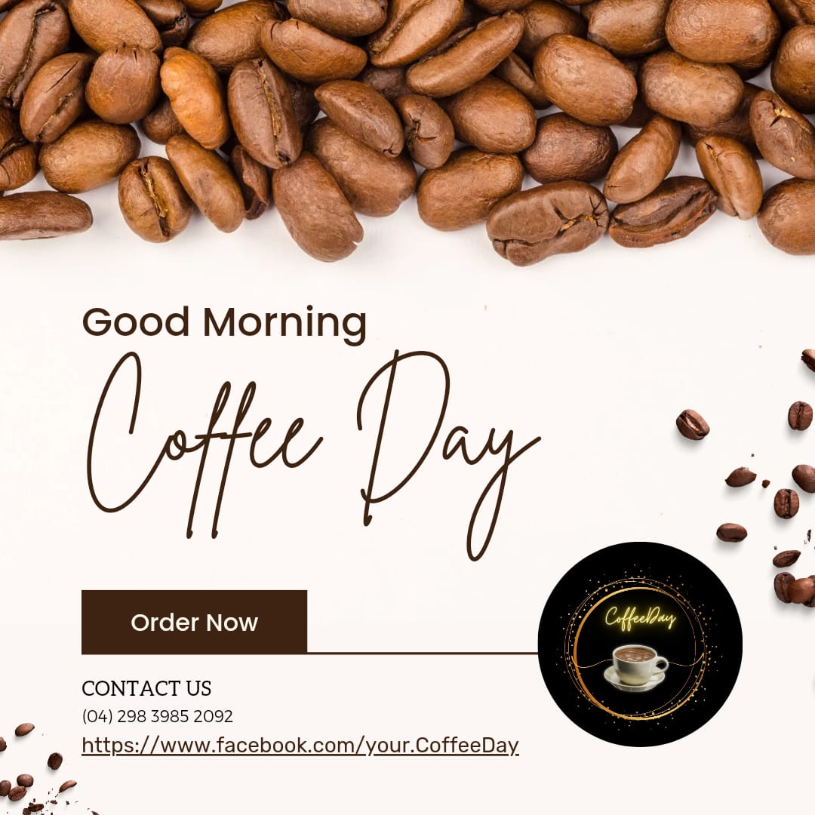

Assignment 4:News Letter Creation
